**Introduction to HTML/CSS**

**Exercise**

1.How are inline and block elements different from each other?

A **block-level element** always starts on a new line and takes up the full width available (stretches out to the left and right as far as it can).

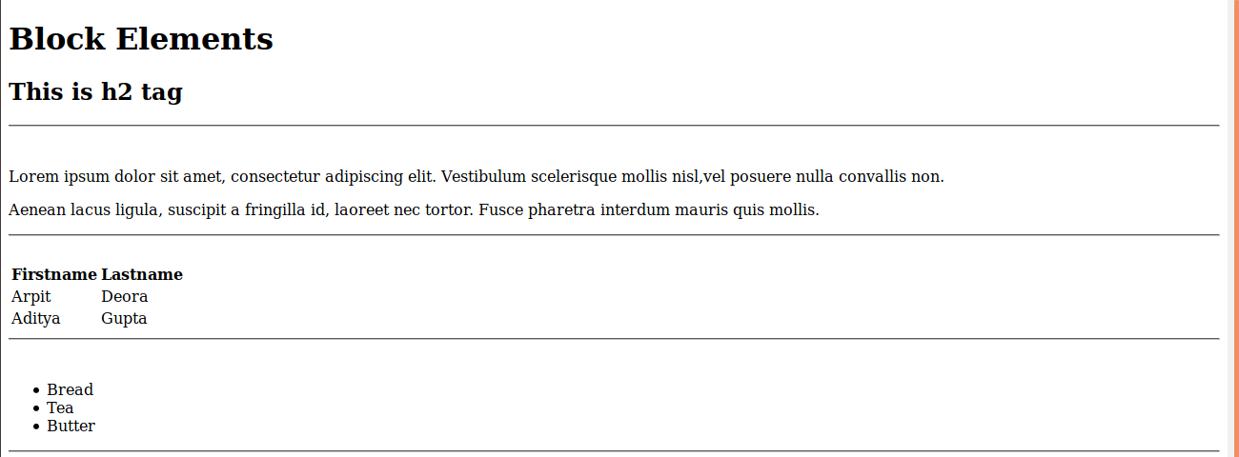

Block level elements in HTML:

<div>,<aside>,<article>,<address>.

An **inline element** does not start on a new line and only takes up as much width as necessary.

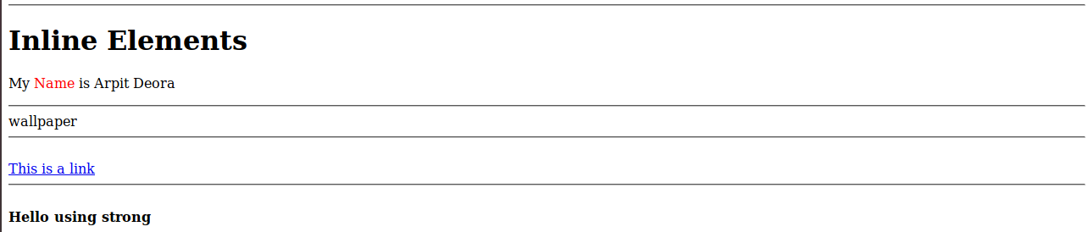

Inline elements in HTML:

<a>,<br>,<i>,<span>.

2.Explain the difference between visibility:hidden and display:none

**display: none;**

It is commonly used with JavaScript to hide and show elements without deleting and recreating them.

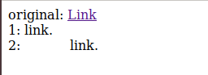

Hiding an element can be done by setting the display property to none. The element will be hidden, and the page will be displayed as if the element is not there:

**Visibility:hidden;**

It also hides an element.However, the element will still take up the same space as before. The element will be hidden, but still affect the layout:

3. Explain the clear and float properties.

The CSS **float property** specifies how an element should float and is used for positioning and formatting content e.g. let an image float left to the text in a container.

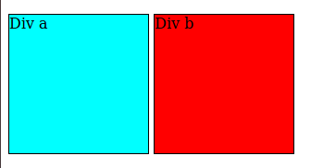

The CSS **clear property** specifies what elements can float beside the cleared element and on which side.

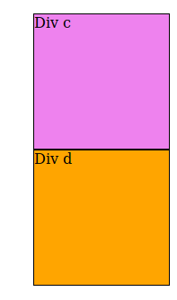

4. explain the difference between absolute, relative,fixed and static.

## **Position: static**

HTML elements are positioned static by default.

Static positioned elements are not affected by the top, bottom, left, and right properties.

An element with position: static; is not positioned in any special way; it is always positioned according to the normal flow of the page:



## **Position: relative**

An element with position: relative; is positioned relative to its normal position.



## **Position: fixed**

An element with position: fixed; is positioned relative to the viewport, which means it always stays in the same place even if the page is scrolled. The top, right, bottom, and left properties are used to position the element.



## **Position: absolute**

An element with position: absolute; is positioned relative to the nearest positioned ancestor (instead of positioned relative to the viewport, like fixed).

However; if an absolute positioned element has no positioned ancestors, it uses the document body, and moves along with page scrolling.

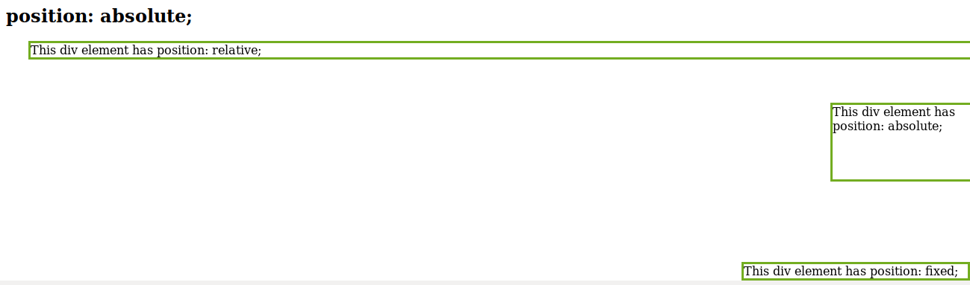

5. Write the HTML code to create a table in which there are 4 columns( ID , Employee Name, Designation, Department) and at least 6 rows. Also do some styling to it.

**CODE:**

<!doctype html>

<html>

<head>

<title>

Table Using Html and CSS

</title>

<style type="text/css">

table {

border: 1px solid black;

}

th, td {

padding: 15px;

text-align: left;

border: 1px solid black;

background-color: Yellow;

}

th {

background-color: #4CAF50;

color: white;

}

</style>

</head>

<body>

<table>

<tr>

<th>Id</th>

<th>Employee name</th>

<th>Designation</th>

<th>Department</th>

</tr>

<tr>

<td>1

<td>Arpit Deora</td>

<td>Trainee</td>

<td>.NET</td>

</tr>

<tr>

<td>2

<td>Aditya Gupta</td>

<td>Trainee</td>

<td>JVM</td>

</tr>

<tr>

<td>3

<td>Azeem Faisal</td>

<td>Trainee</td>

<td>.NET</td>

</tr>

<tr>

<td>4

<td>Shreya Tiwari</td>

<td>Trainee</td>

<td>JVM</td>

</tr>

<tr>

<td>5

<td>Deepak Jha</td>

<td>Trainee</td>

<td>Android</td>

</tr>

<tr>

<td>6

<td>Preeti Upadhaye</td>

<td>Trainee</td>

<td>JVM</td>

</tr>

</table>

</body>

</html>

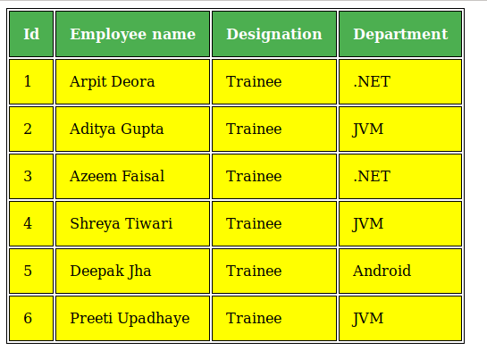

6. Why do we use meta tags?

The <**meta**> **tag** provides **metadata** about the **HTML** document. **Meta elements are** typically **used** to specify page **description**, **keywords**, author of the document, last modified, and other **metadata**. The **metadata can** be **used** by browsers (how to display content or reload page), search engines (**keywords**), or other web services.

<!DOCTYPE html>

<html>

<head>

<meta charset="UTF-8">

<meta name="description" content="Metadata description">

<meta name="keywords" content="HTML,CSS">

<meta name="author" content="Arpit Deora">

<meta name="viewport" content="width=device-width, initial-scale=1.0">

</head>

<body>

<p>This is a webpage describing meta tags in HTML</p>

</body>

</html>

7. Explain box model.

All HTML elements can be considered as boxes. In CSS, the term "box model" is used when talking about design and layout.

The CSS box model is essentially a box that wraps around every HTML element. It consists of: margins, borders, padding, and the actual content.

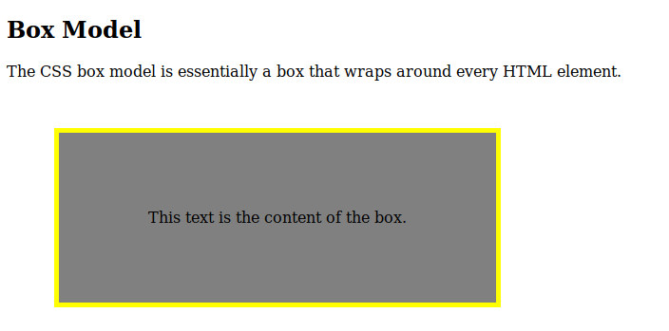

8. What are the different types of CSS Selectors?

## **The CSS id Selector**

The id selector uses the id attribute of an HTML element to select a specific element and the id of an element is unique within a page, so the id selector is used to select one unique element!

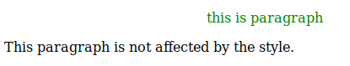

## **The CSS Universal Selector**

The universal selector (*) selects all HTML elements on the page.

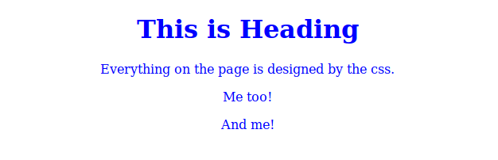

## **The CSS Grouping Selector**

The grouping selector selects all the HTML elements with the same style definitions.



9. Define Doctype.

The <!DOCTYPE> declaration must be the very first thing in your HTML document, before the <html> tag.

The <!DOCTYPE> declaration is not an HTML tag; it is an instruction to the web browser about what version of HTML the page is written in.

In HTML 4.01, the <!DOCTYPE> declaration refers to a DTD, because HTML 4.01 was based on SGML. The DTD specifies the rules for the markup language, so that the browsers render the content correctly.



10. Explain 5 HTML5 semantic tags.

The <article> element specifies independent, self-contained content. An article should make sense on its own, and it should be possible to read it independently from the rest of the web site.

The <header> element specifies a header for a document or section.The <header> element should be used as a container for introductory content.

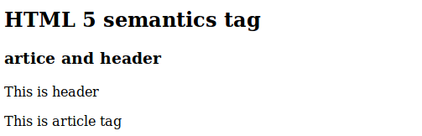

The <section> element defines section in a document.

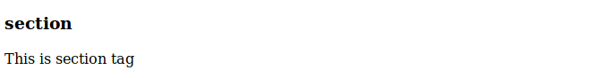

The <nav> element defines a set of navigation links.



The purpose of a figure caption is to add a visual explanation to an image.In HTML5, an image and a caption can be grouped together in a <figure> element.The <img> element defines the image, the <figcaption> element defines the caption.

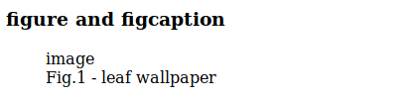

The <footer> element specifies a footer for a document or section. A <footer> element should contain information about its containing element. A **footer** typically contains the author of the document, copyright information, links to terms of use, contact information, etc.

